

**Green University of Bangladesh**

**Department of Computer Science and Engineering (CSE)**

**Faculty of Sciences and Engineering**

**Semester: (Summer, Year:2022), B.Sc. in CSE (Day)**

**CT3 & Course Assignment**

**Course Title:** Structured Programming

**Course Code:** CSE-103 **Section: D2**

**Student Details**

| **Name** | | **ID** |
| --- | --- | --- |
| **1.** | Tanvir Ahmed | 221002461 |

**Submission Date :** 13-09-2022

**Course Teacher’s Name : Prof. Dr. Md. Saiful Azad**

Chairperson and Professor

| **Status (**Don’t write anything here**)**  **Marks: ………………………………… Signature:.....................**  **Comments:.............................................. Date:..............................** |
| --- |

1: Calculate grade from given marks. (use grading system of Green University).

#include<stdio.h>

int main()

{

float mark;

printf("Enter your mark: ");

scanf("%f", &mark);

if (mark>=0 && mark<40)

printf("Grade: F");

else if (mark>=40 && mark <45)

printf("Grade: D");

else if (mark>=45 && mark<50)

printf("Grade: C");

else if (mark>=50 && mark<55)

printf("Grade: C+");

else if (mark>=55 && mark<60)

printf("Grade: B-");

else if (mark>=60 && mark<65)

printf("Grade: B");

else if (mark>=65 && mark<70)

printf("Grade: B+");

else if (mark>=70 && mark<75)

printf("Grade: A-");

else if (mark>=75 && mark<80)

printf("Grade: A");

else if (mark>=80 && mark<=100)

printf("Grade: A+");

else

printf("Wrong mark provided.");

return 0;

}

Output:

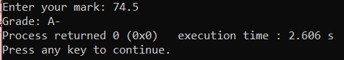

2: Find out sum of the numbers in an array.

#include<stdio.h>

int main()

{

int n;

printf("Enter how many numbers you want to sum: ");

scanf("%d", &n);

int ar[n];

printf("Enter the numbers: ");

for(int i=0; i<n; i++)

scanf("%d", &ar[i]);

int sum=0;

for(int j=0; j<n; j++)

sum += ar[j];

printf("Sum of all numbers is: %d", sum);

return 0;

}

Output:

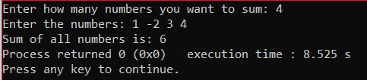

3: Separate the odd and even numbers from an array and put it in other arrays called oddArray and evenArray.

#include<stdio.h>

int main()

{

int n;

printf("Enter how many numbers: ");

scanf("%d", &n);

int ar[n];

printf("Enter the numbers: ");

for(int i=0; i<n; i++)

scanf("%d", &ar[i]);

int oddArray[n], evenArray[n], o=0, e=0;

for(int i=0; i<n; i++)

{

if (ar[i]%2==0)

{

evenArray[e] = ar[i];

e++;

}

else

{

oddArray[o] = ar[i];

o++;

}

}

printf("Even numbers: ");

for(int k=0; k<e; k++)

printf("%d ", evenArray[k]);

printf("\n");

printf("Odd numbers: ");

for(int l=0; l<o; l++)

printf("%d ", oddArray[l]);

return 0;

}

Output:

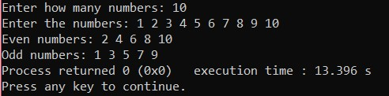

4: Separate the prime numbers from an array into another array called primeArray.

#include<stdio.h>

#include<math.h>

#include<stdbool.h>

int main()

{

int n;

printf("Enter how many numbers:" );

scanf("%d", &n);

int ar[n],primeArray[n], x=0;

printf("Enter the numbers: ");

for(int i=0; i<n; i++)

scanf("%d", &ar[i]);

for(int j=0; j<n; j++)

{

bool flag = true;

if(ar[j]==0 || ar[j]==1)

flag=0;

for(int k=2; k <= sqrt(ar[j]); k++)

{

if(ar[j]%k==0)

{

flag = false;

break;

}

}

if(flag==true)

{

primeArray[x] = ar[j];

x++;

}

}

printf("Prime numbers: ");

for(int i =0; i<x; i++)

{

printf("%d ", primeArray[i]);

}

return 0;

}

Output:

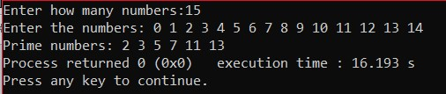

5: Sum of numbers in Fibonacci series until nth position.

#include<stdio.h>

int main()

{

int x;

printf("Enter the position of fibonacci series: ");

scanf("%d", &x);

int m=0, n=1, next, sum=0;

for(int i=0; i<x; i++)

{

if(i <=1)

next =i;

else

{

next = n+m;

m=n;

n = next;

}

sum+=next;

printf("%d ", next);

if(i<x-1)

printf("+ ");

}

printf("= %d", sum);

}

Output:

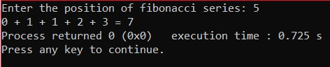

6: Find out largest, smallest, average number in an array.

#include<stdio.h>

int main()

{

int n;

printf("Enter how many numbers: ");

scanf("%d", &n);

printf("Enter numbers: ");

int ar[n];

for(int i=0; i<n; i++)

scanf("%d", &ar[i]);

int max = ar[0], min = ar[0];

float sum=0;

for(int j=0; j<n; j++)

{

sum += ar[j];

if(max<ar[j])

max = ar[j];

if(min>ar[j])

min = ar[j];

}

float avg = sum/n;

printf("Largest: %d\n", max);

printf("Smallest: %d\n", min);

printf("Average: %.2f\n", avg);

}

Output:

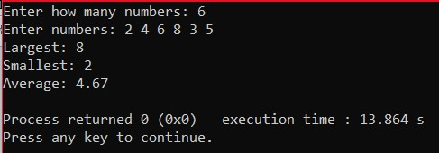

7: find out nCr, nPr for given value of n & r (define recursive function for factorial)

#include<stdio.h>

int fact(int n)

{

int F=1;

if(n>0)

F = n*fact(n-1);

return F;

}

int main()

{

int n, r, C, P;

printf("Enter n & r: ");

scanf("%d %d", &n, &r);

P = fact(n)/fact(n-r);

C = fact(n)/ (fact(r)*fact(n-r));

printf("nCr = %d\n", C);

printf("nPr = %d", P);

}

Output:

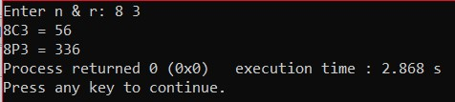

8: Convert a string from upper case to lower case and lower case to upper case.

#include<stdio.h>

int main()

{

char ar[100];

printf("Enter a string: ");

gets(ar);

for(int i=0; ar[i]!='\0'; i++)

{

if(ar[i]>='A' && ar[i]<='Z')

ar[i] +=32;

else if(ar[i]>='a' && ar[i]<='z')

ar[i] -=32;

}

puts(ar);

}

Output:

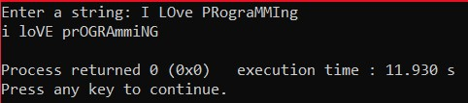

9: Concatenate string without using strcat()

#include<stdio.h>

int main()

{

char f[100], s[100];

printf("Enter first string: ");

gets(f);

printf("Enter second string: ");

gets(s);

int i;

for(i=0; f[i]!='\0'; i++);

f[i] = ' ';

i++;

for(int j=0; s[j]!='\0'; j++)

{

f[i] = s[j];

i++;

}

puts(f);

}

Output:

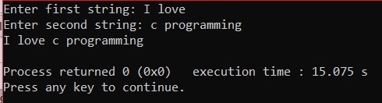

10: print reverse of a string inputted by user.

#include<stdio.h>

int main()

{

char ar[100], rar[100];

printf("Enter a string: ");

gets(ar);

int i;

for(i=0; ar[i]!='\0'; i++);

i--;

for(int j=0; ar[j]!='\0'; j++)

{

rar[i] = ar[j];

i--;

}

puts(rar);

return 0;

}

Output:

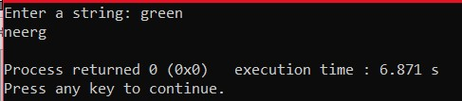

11: Print The Pattern (Pyramid)

#include<stdio.h>

int main()

{

int n;

printf("Enter a number: ");

scanf("%d", &n);

for(int i=1; i<=n; i++)

{

for(int j=1; j<=n-i; j++)

printf(" ");

for(int j=1; j<=i; j++){

printf("*");

printf(" ");

}

printf("\n");

}

return 0;

}

Output:

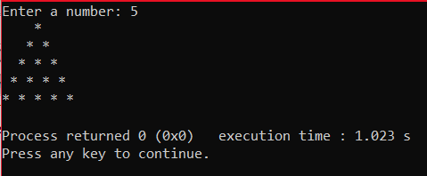

12: Create a function which receives a pointer of array as a parameter and calculates the sum of prime numbers and sum of non_prime numbers in that array. Then compares them to find out which one is larger (sum of prime or sum of non_prime). Return both sum of prime and sum of non_prime numbers also and print those in the main function.

#include<stdio.h>

#include<stdbool.h>

void spnp(int *ar, int n, int *sumofprime, int *sumofnonprime, int *large )

{

int prime[n], nonprime[n], x=0, y=0;

for(int j=0; j<n; j++)

{

bool flag = true;

if(*(ar+j)==0 || *(ar+j)==1)

flag=false;

for(int k=2; k <= *(ar+j)/2; k++)

{

if(*(ar+j)%k==0)

{

flag = false;

break;

}

}

if(flag==true)

{

prime[x] = *(ar+j);

x++;

}

else

{

nonprime[y]= *(ar+j);

y++;

}

}

printf("Prime: ");

for(int k=0; k<x; k++)

printf("%d ", prime[k]);

printf("\n");

printf("Non prime: ");

for(int l=0; l<y; l++)

printf("%d ", nonprime[l]);

printf("\n");

*sumofprime =0;

*sumofnonprime=0;

for(int i=0; i<x; i++)

*sumofprime += prime[i];

for(int j=0; j<y; j++)

*sumofnonprime += nonprime[j];

if(*sumofprime<*sumofnonprime)

*large = *sumofnonprime;

else

*large = *sumofprime;

}

int main()

{

int n;

printf("Enter how many number: ");

scanf("%d", &n);

printf("Enter the numbers: ");

int ar[n];

for(int i=0; i<n; i++)

scanf("%d", &ar[i]);

int sop, sonp, l;

spnp(ar, n, &sop, &sonp, &l);

printf("The sum of prime numbers is: %d\n", sop);

printf("The sum of non prime numbers is: %d\n", sonp);

if(l==sonp)

printf("Sum of nonprime is the large.");

if(l == sop)

printf("Sum of prime is the large. ");

return 0;

}

Output:

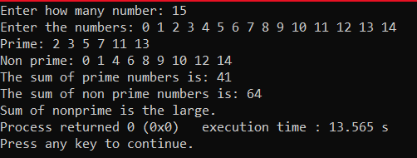

13: Suppose you want to send a message to your friend but don’t want others to understand that message. So, you have decided to encrypt the message. Now, suppose the message is in a string variable called MSG. a) You have to encrypt the message and change the string so that others cannot understand it. b) Again, decrypt the encrypted message.

#include<stdio.h>

int main()

{

char ar[100];

printf("Enter a message: ");

gets(ar);

for(int i=0; ar[i]!='\0'; i++)

ar[i] += 5;

printf("Encrypted message: ");

for(int j=0; ar[j]!='\0'; j++)

printf("%c", ar[j]);

printf("\n");

for(int i=0; ar[i]!='\0'; i++)

ar[i] -=5;

printf("Decrypted message: ");

for(int j=0; ar[j]!='\0'; j++)

printf("%c", ar[j]);

return 0;

}

Output:

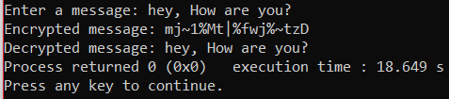

14: Create a function to compare the elements of 2 arrays. Function should receive two pointers to an array and then check if the elements are same in both arrays or not. If both arrays are same return true, otherwise, false.

#include<stdio.h>

#include<stdbool.h>

bool compare(int *ar1, int *ar2, int n)

{

for(int i=0; i<n; i++)

{

if(*(ar1+i)!=*(ar2+i))

{

return false;

break;

}

}

return true;

}

int main()

{

int n;

printf("Enter the size: ");

scanf("%d", &n);

int ar1[n], ar2[n];

printf("Enter the first array: ");

for(int i=0; i<n; i++)

scanf("%d", &ar1[i]);

printf("Enter the second array: ");

for(int i=0; i<n; i++)

scanf("%d", &ar2[i]);

//compare(ar1, ar2, n);

if(compare(ar1, ar2, n)== true)

printf("Both array are same. ");

else printf("Arrays are not same.");

return 0;

}

Output:

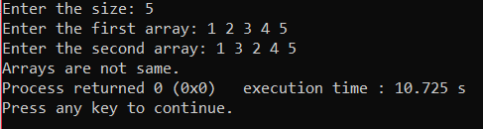

15: Create a staff/worker information system using C Struct where you’ll be able to –

a) Insert staff/worker details with id, name and monthlySalary

b) Display staff/worker details (searched by id)

c) Update monthlySalary of a staff/worker

#include<stdio.h>

struct staff

{

int id;

char name[50];

int msalary;

}staffar[100];

int indx =0;

void add(int n)

{

printf("Enter id: ");

scanf("%d", &staffar[n].id);

fflush(stdin);

printf("Enter name: ");

gets(staffar[n].name);

printf("Enter Monthly salary: ");

scanf("%d", &staffar[n].msalary);

fflush(stdin);

}

void display (int x)

{

for (int i=0; i<x; i++)

{

printf("id : %d \n", staffar[i].id);

printf("Name: %s \n", staffar[i].name);

printf("Monthly salary: %d \n", staffar[i].msalary);

}

}

void update()

{

int y;

printf("Enter id of staff: ");

scanf("%d", &y);

for(int i=0; i<indx; i++)

{

if(staffar[i].id == y)

{

printf("Enter updated salary: ");

scanf("%d", &staffar[i].msalary);

break;

}

}

}

int main()

{

int select;

do

{

printf("Choose a option: \n"

"1: Add staff information.\n"

"2: Display staff details. \n"

"3: Update. \n");

scanf("%d", &select);

switch (select)

{

case 1:

add(indx++);

break;

case 2:

display(indx);

break;

case 3:

update();

break;

default :

printf("Wrong option chosen. ");

}

printf("If you want to continue press 1 otherwise press 0: ");

scanf("%d", &select);

}

while (select == 1);

return 0;

}

Output:

